The Atonement

I. The atonement is the work that Jesus accomplished through His death on our behalf.

A. In a sense, the entire revelation of Scripture revolves around the atonement.

B. “Atonement” is a beautiful word, but many people don’t actually know what it really means. To help us understand it, the word ‘atonement” is made up of three sections: AT – ONE – MENT. Atonement is “at-one-ment”. Atonement restores the sinner back into God’s favor. It’s reconciliation. It’s bringing God and the sinner, who’ve been alienated. AT-ONE. It’s “at-one-ment”.

C. Atonement is “union”. (Col 1:27, 2Cor. 5:17) “Christianity is not effort, it’s union. It’s not striving, it’s yielding.” DEREK PRINCE

II. A picture that illustrates the place of the atonement in the total message of the Gospel, is the picture of a wheel.

A. In a wheel, simplistically, there are 3 sections: the outer circle, the spokes, and the hub. In this picture, the outer circle represents God’s complete provision for every area of our life: spiritual, physical, financial, mental, emotional for time and eternity. The spokes that support the outer wheel are the ways that God makes provision.

B. Some examples of spokes are: receiving Communion that activates our faith, giving tithes and offerings that bring us into financial blessing, praising God that brings us deliverance from anxiety, and repentance that brings forgiveness and peace.
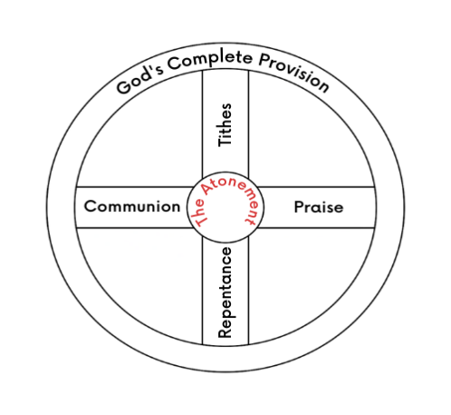
C. So, the spokes support the outer rim which is God’s provision. But the HUB, the very center of the wheel, is the atonement. The spokes rest upon the hub. Without the hub, the spokes don’t have anything to support them. Also, through the hub, there comes the driving power that turns the wheel. In God’s provision, the atonement is the hub. It’s the center. It’s that on which everything else depends. Spiritually speaking, the hub supplies the power for the Christian life.

D. As we look at the picture of the wheel, we can see that power flows from the hub through the spokes and into the outer rim causing the wheel to move.
III. More spokes, although there are many more actions steps stated in Scripture.

Action step (spoke) God’s complete provision for time and for eternity (the outer circle)

Communion Activates faith (James 2:14) (1 Cor. 10:16)
Tithes and offerings Financial provision (Mal. 3:10) (Lk 6:38)
Praise Deliverance from anxiety (Isa 61:3) (Ps. 8:2)
Repentance Salvation, forgiveness and peace (Lk. 13:3) (1 Jn. 1:9) (Eph. 2:14)

Calling for the elders
to anoint with oil Physical healing (James 5:14-15)

Receiving the baptism
of the Holy Spirit Divine power to be witnesses (Acts 1:8)

Baptism Spiritual circumcision giving greater liberty from sin (Col. 2:11)
Forgiving others Liberty from bitterness (Heb. 12:15)
Praying for Israel Prosperity, salvation of Jewish people (Ps. 122:6)
Praying for our government Living quiet and peaceful lives in godliness (1 Tim. 2:1-2)

IV. We see the work of at-one-ment that Jesus accomplished through His death in Heb. 2:9 and Isaiah 53:5-6. Both passages speak of Jesus as He died on the cross on our behalf.

Hebrews 2:9 (NLT) What we do see is Jesus, who for a little while was given a position “a little lower than the angels”; and because he suffered death for us, he is now “crowned with glory and honor.” Yes, by God’s grace, Jesus tasted death for everyone.

Isaiah 53:6 All we like sheep have gone astray; We have turned, every one, to his own way; And the Lord ^{[n]}has laid on Him the iniquity (rebellion) of us all.

V. What God has laid on Jesus because of our rebellion What is available to us now

DEATH ETERNAL LIFE
SIN RIGHTEOUSNESS
GUILT LIBERTY IN OUR MIND
SHAME HONOR
REJECTION ACCEPTANCE
SICKNESS HEALING AND HEALTH
POVERTY ABUNDANCE
CURSES BLESSINGS

